Experian Aperture

Data Studio

Component Standard

Version control
Version | Date | Author/updated by | Comments
0.01 | 2025-02-14 | Kelvin Tam | First Draft

Note:
Dates in ISO format: YYYY-MM-DD
Versions: 0.XX Pre-release, n.XX Release, n.XX.xx draft releases of version under version control
Contents
Overview 5
Drivers and Motivation 5
Business Value 5
Considerations 6
Security Considerations 6
Cost Optimization 6
Operational Excellence 6
Reliability 6
Performance Efficiency 6
Sustainability 6
Functionality / How it Works 7
Architectural Attributes 8
Interfaces 8
Redundancy, Availability & Reliability 8
Scale, Elasticity & Capacity 8
Cost, Business & Support Models 8
User Access & Roles 9
Federated Roles 9
Access Control Policies 9
Restrictions 9
Permitted Regions 9
Use Cases 10
Single Signon and Single Logout 10
Routine Bulk Data Scan and /or Enrichment 10
Realtime Data Validation and/or Enrichment 11
Cleanse, Enrich and Transform Data Ingestion 11
Data & Governance 13
Data Classification 13
Guardrails 13
Splunk Real-time Security Monitoring 13
Neptune Global Logging for Observability 14
API Gateway Interface 14
Capabilities and Product Comparison 15
Capability Table 15
Component Comparison 15
Exceptions 16
Related links to other architectural documents used at Aegon 17
Related Component Standards 17
Architectural Patterns 17
Reference Architecture 17
Solution Architectures 17

Overview
Experian Aperture Data Studio offers data quality controls to improve the accuracy, consistency, and reliability of the data used in operation and decision-making. It offers automated tools for data cleansing, validation, and enrichment. These tools help identify and correct errors, remove duplicates, and standardize data.

Drivers and Motivation
Many of our competitors started significant data transformation efforts five or more years ago. These efforts have put them in a better position to manage the business effectively and identify new opportunities in the market.

Data Quality is a key internal challenge facing all Aegon BUs. These issues lead to manual work and validation that drive up costs and introduce new risks to the firm.

Business Value
- This is a high-level priority item within the Global Data Office and has senior management visibility.
- The largest opportunities to create value from our data are centered around improving data quality, reducing data fragmentation due to legacy data systems and removing the manual manipulation of data in our core processes. This will reduce costs and lead to better insights with more accurate, reliable, and trustworthy data.
- Data quality metrics will help to identify gaps, trends and patterns and help to direct resources to the right place for maximum value.
- Data quality indicators will address organizational lack of trust in data.
- Data quality indicators will help shield Aegon from corporate liability in handling of sensitive data.

Considerations
With a view to the Azure and AWS Well Architected Frameworks, consider how the component should be configured under the following contexts.

Security Considerations
- Data encryption in transit and at rest to securely transfer and store data.
- Role-based access control for defining and restricting user access to sensitive information based on roles and responsibilities.
- Data access and modification audit trail for transparency and accountability.

Cost Optimization
- Centralize and optimize data management leveraging economy of scale and reducing data redundancy cost.
- Centralize data quality governance and controls to improve data accuracy and consistency and mitigate data related risks.
- Automation and streamline data exchange to improve collaboration and operation efficiency which reduces operational cost.

Operational Excellence
- Aperture Data Studio promotes data integration efficiency
- Improves company data integrity
- Cloud infrastructure
- Scalable and reliable platform

Reliability
- Scalability feature to scale horizontally to be responsive to increasing data volumes and workloads
- Data is replicated across multiple locations to be ready for disaster or outage recovery
- System health and performance are monitored to identify issues before they impact operations that affect availability.

Performance Efficiency
- Elastic scalability architecture let Aperture Data Studio automatically scale resources based on workload demands
- Parallel processing feature lets it scale horizontally to handle multiple data tasks simultaneously.
- Caching mechanism allows it to store frequently access data to reduce retrieval time and load on underlying components.
- Real-time data processing and optimized data pipelines help streamline data ingestion.

Sustainability
- Initial discounted startup first year
- Relatively fixed total cost of operation year to year.

Functionality / How it Works
Experian Aperture Data Studio is a data quality management software. It can be deployed as a SaaS or deployed to GTS AWS cloud (preferred). It lets users create data quality rules and workflows to routinely scan data or scan in small datasets in real-time to identify issues that can be tracked and resolved with subsequent scans. It has data connectivity to most data sources. It can also combine data from multiple sources to return a cleansed and enriched dataset that can be used to improve data at the sources. Below are the main data features.

Data Integration: Aperture Data Studio allows users to integrate data from multiple sources, including internal databases, external data providers, and cloud-based systems. It helps consolidate diverse data into a unified view, providing a comprehensive foundation for analysis.

Data Quality Controls: It offers robust tools for cleansing, validating, and enriching data. The platform identifies and corrects errors, removes duplicates, and standardizes data, ensuring accuracy and consistency for better operation and decision-making.

Advanced Analytics: Aperture Data Studio uses machine learning and advanced analytics to provide actionable insights. It helps businesses analyze customer behavior, predict outcomes, assess risk, and generate data-driven recommendations.

Real-Time Processing: The platform processes data in real-time, enabling businesses to make immediate, data-informed decisions.

Visualization and Reporting: Users can create visualizations and reports to interpret complex data. The intuitive interface allows for quick analysis, helping users identify trends, opportunities, and areas for improvement.

Decisioning and Automation: The platform automates decision-making processes, using predefined rules and machine learning models to apply insights in real-time, enabling faster and more efficient actions.

Workflow: Data from various sources is imported into the platform to undergoes data transformation and data quality control. Machine learning algorithms and analytics models can be applied to uncover trends, make predictions and generate insights which can be used to automate decision-making processes to trigger actions or raise data gap incidents. All the while, users can monitor activities, generate dashboards and reports to track KPIs and data gap incidents to resolution.

Architectural Attributes

Interfaces
- Data Preparation Interfaces offers a graphical workflow designer to integrate, clean, enrich, validate and transform data.
- Data Connections
  - Java Database Connectivity (JDBC)
  - Apache Hadoop HDFS
  - Amazon S3
  - Microsoft Azure Blob Storage (Data Lake Gen2)
  - SFTP including Experian STS
  - Add-ons Driver and 3rd Party Drivers: Data Quality user documentation | Configure External systems
- Analytics Interface lets users create and deploy machine learning models and statistical models, analyze data sets, and generate insights.
- Reporting and Visualization Interface enables users to create dashboards, reports and visualizations with interactive charts and graphs.
- API Interface is used to integrate with other enterprise systems access data, models and analytic results. Other systems can use this interface to trigger workflows within the platform.

Redundancy, Availability & Reliability
See Considerations section above

Scale, Elasticity & Capacity
See Considerations section above

Cost, Business & Support Models
The Experian Aperture data quality platform will be centrally owned and managed by the Global Data Office to provide a consistent and scalable approach to data quality across all business units. This model ensures a standardized framework while allowing flexibility in rule development, either through internal resources or a managed service with a third party.
See Operating Model for Data Quality Platform
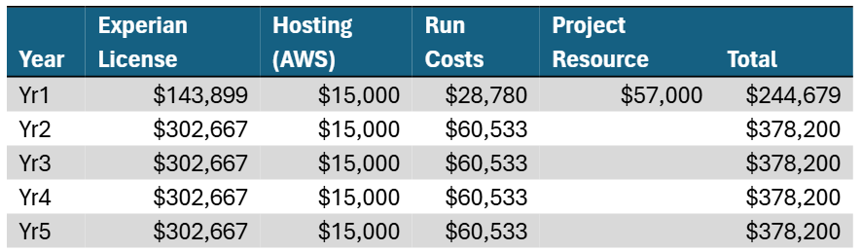

User Access & Roles
Define the users and roles that are required to use the component in a compliant manner.
Emphasize the use of fine-grained security controls and separation of concerns.

Federated Roles
Experian Aperture Data Studio SSO works with PingOne. RBAC is managed based on AD groups or roles (Data Analysts, Admins, Business Users). User roles mapped to AD groups simplify user provisioning and de-provisioning as well as integration with SailPoint for annual entitlement reviews.
See Operating Model for Data Quality Platform

Access Control Policies
RBAC roles mapped to AD groups

Restrictions
None

Permitted Regions
Experian Aperture Data Studio will be offered as a global service residing on GTS AWS cloud approved regions.

Use Cases / Patterns
Describe potential use cases. These can be references to provide use cases (such as linking to AWS documentation), or to Aegon Reference Architectures and Architecture Patterns.

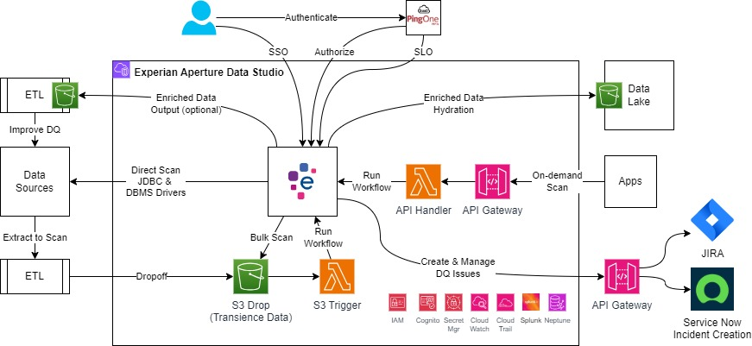

Single Sign-on and Single Logout with PingOne
Enable Ping/PingOne SSO to Aperture for users.
- Data Steward – Oversee data quality by creating data quality rules and workflows
- Data Architect – Design data architecture and strategy
- Data Analyst – Analyze and interpret data
- Business Analyst – Define data quality rules based on business operations
- Data Engineer – build infrastructure and process data
- Administrator – Configure Aperture and manage security and access
- Business Users – Use dashboards and reports
- Compliance Officer – Ensure that data management practices comply with policies
- QA Tester – Verify that rules and workflows are functioning as expected
Requirements
- Role-based access control mapping AD groups to Aperture roles. SAML assertion provides authenticated user AD group information.
- Multi-factor authentication is required for PingOne authentication.
- Single logout terminates Aperture sessions when a user logout of Ping/PingOne.

Bulk Data Scan and /or Enrichment
Applications routinely export data for scanning, identifying data issues, enriching data and monitoring data quality improvement over time. This is implemented using S3 to receive data drop off and trigger validation workflow. Optionally enriched data is written to S3 for applications to pick up and update the data sources.

Real-time Data Validation and/or Enrichment
Applications use Aperture to validate user data entry by sending single record dataset in for validation and receive response and/or enriched data back in real time. This is implemented using an API Gateway to request data validation and receive response.

Cleanse, Enrich and Transform Data Ingestion
Use already established data validation rules and workflows to cleanse, enrich and transform source data for warehousing and published datasets.

Create and Manage Data Issues – ServiceNow (preferred) or JIRA
Aperture Data Studio can integrate with ServiceNow and JIRA to create, track, update and close data issues or incidents through the GTS SaaS/PaaS API Gateway.

Data & Governance
Aperture Data Platform supports the following features to protect PII, PHI and sensitive data in addition to data encryption in transit and at rest and role-based access controls.
- Data Masking obfuscates PII and PHI during processing and analysis hiding sensitive data that are not necessary for the task.
- Data Redaction obscures PII and PHI data from being visible when displaying on dashboard or on sharing reports.
- Data Anonymization randomize identifying data to not expose personal information during processing and analysis.
- Implement data segmentation to remove or isolate PII and PHI from other data in the platform when not sensitive data is not needed for analysis and reporting.

Data Classification
Refer to the ITCF Framework and ICTF P04.01.02 Information Security Classification Standard for guidance on data classification the controls for processing, storing and transmitting data.
- Public: Can be used to transfer public files, such as marketing materials or product documentation.
- Internal: Can be used to transfer internal files, such as personal information in a defined context or operational guidelines.
- Confidential: Can be used to transfer sensitive files, such as personal information related to employees, business/marketing plans.
- Strictly Confidential: Can be used to transfer very sensitive files, such as healthcare data or government classified information, trade secrets, strategic plans.
  - PII: Can be used to transfer personally identifiable information (PII), such as names, addresses, and Social Security numbers.
  - HIPAA: Is HIPAA eligible, meaning it can be used to transfer healthcare data in compliance with the Health Insurance Portability and Accountability Act (HIPAA).

These are recommended guidelines for data rules that Aperture Data Studio can detect, enforce or remediate.
Methods | Use Case | Data Classification
Data Segmentation | When not needed | PII, PHI, PCI
Masking | When needed for context | PHI, PCI
Redaction | When needed for visualization | All sensitive data
Anonymization | When needed for non-identifying context | PHI

Guardrails
List the guardrails that need to be implemented to properly control the use of the component.

Splunk Real-time Security Monitoring
Interface with Splunk to establish real-time monitoring of activities for all interfaces via CloudTrail.

Neptune Global Logging for Observability
Stream activity logs from CloudWatch to Neptune for observability, performance and health monitoring dashboard.

API Gateway Interface
Deploy API gateway to provide consistent authentication and authorization of data exchange and interaction with other applications. Network through Imperva & Hosting service for external inbound connections; through Inspection service for internal inbound connections; and through Browsing service for outbound connections.

Capabilities and Product Comparison
When to use, or not use this component. Include references to alternative products if possible.

Capability Table
A table of capabilities of this component with a description and some indication of the weight of the capability used for the selection of the overall component.
Capability | Description | Requirement
Data Integration and Management |  | Must Have
Data Quality and Governance |  | Must Have
Advanced Analytics and Machine Learning |  | Optional
Decisioning and Automation |  | Optional
Visualization and Reporting |  | Must Have
Data Security and Compliance |  | Must Have

Component Comparison
A table of capabilities (features) in the same component-class, identifying key features, advantages and disadvantages based on the Architectural Attributes above.
Capability | <this Component> | Alternative Component | Selection Criteria

Please see DQ POC comparison result.

Exceptions
Describe any exceptional circumstances that require this particular component.
Describe any circumstances when this component should NOT be used.

None

Related links to other architectural documents used at Aegon

Related Component Standards
Such as other products in the same category that have Component Standards
- Component Standard name and hyperlink
- Component Standard name and hyperlink

Architectural Patterns
A list of links to Architectural Patterns based on this component.
- Architectural Pattern name and hyperlink
- Architectural Pattern name and hyperlink

Reference Architecture
A list of links to Reference Architectures that consume this component.
- Reference Architecture name and hyperlink
- Reference Architecture name and hyperlink

Solution Architectures
A list of links to Solution Architectures that consume this component.

- Solution Architecture name and hyperlink
- Solution Architecture name and hyperlink

